(Approx. 634 words)

Blocking Unwanted Email
By David Kretchmar, Computer Technician
Sun City Summerlin Computer Club
https://www.scscc.club
dkretch (at) gmail.com

Sooner or later this happens to all of us. You continuously receive unwanted emails, (spam) from an individual or organization. Legitimate organizations usually have an Unsubscribe button within their message, which enables you to be dropped from their email list. If you attempt to unsubscribe from a less-than-legitimate mailer you are just confirming that your email address is good and even more spam will come your way.

Some individuals will not respect your request to stop sending (usually forwarding) you useless or offensive messages; more charitably they might lack the knowledge to be able to remove you from their mail distribution list.

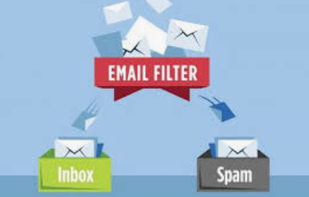
Unwanted emails can be more than just bothersome or offensive. Some contain viruses that can render your system useless and destroy your data. Some people have had to abandon email addresses when they received many dozens of unwanted emails every day.

Fortunately, all email programs have a feature that will allow you to block all emails from specific email addresses.

I’m going to describe the email blocking procedures for three popular web-based email programs: Yahoo Mail, Outlook, and Gmail. If you are using another email provider, the described procedures can be used to at least point you in the right direction.

Each of these programs allows you to use a list of blocked senders for individual senders whose messages you don't want to receive but can't easily stop.

Yahoo Mail
Yahoo Mail can block all mail from up to 500 email addresses. All mail from these senders will be automatically deleted before you see it. To have Yahoo! Mail automatically delete all mail from a particular address:

- Left mouse click (hereafter I’ll just say click if it’s left) or just put your cursor on the settings gear in the upper right corner of the Yahoo Mail page.
- Click on “Mail Options” from the pull-down menu that has appeared.
- Click “Blocked Addresses” category under Advanced Options.
- Enter the unwanted email address under “Add an address:”.
- Click on “+”.

Your updated list of blocked senders will be saved automatically.

Outlook
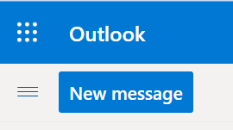
- Click on the gear that appears in the upper right
corner of the Outlook mail window.
- Click on “More mail setting”.
- Click on “Safe and blocked Senders”.
- Click on “Blocked senders”.
- Enter the unwanted email address in the “Blocked
email address or domain” rectangle.
- Click on “Add to list>>”

Your updated list of blocked senders will be saved automatically.

Gmail
- Click on the Settings gear that appears on the upper right corner of the Gmail window.
- Click on “Filters” near the top middle of the page.
- Click on “Create a new filter” at the bottom of the page.
- Enter the unwanted email address in the “From” rectangle.
- Click on “Create filter with this search>>”.
- Click on “Delete it”.
- Click on “Create Filter”.

Conclusions and Recommendations
Never reply to or unsubscribe from spam; it just alerts the sender that it has a good email address. When you get a spam message, click on your program’s “Spam” or “Send to Spam” or “Report as spam” to get rid of it and help your email provider learn to block messages from that server.

Even though email providers have active programs to help stop spam, it still comes. What winds up in your inbox is just a small fraction of the trash that is sent your way. Spammers are constantly changing techniques to defeat any filters.

You can work around the problem by creating and maintaining a “junk” or “throw down” email address that you know will be mostly spam. When I have to give out an email address to a website that I feel might be questionable, I provide the junk address and avoid possible spam in my “good” inboxes.

